**TABLE OF CONTENT**

Requirement……………………………………………………………………………………………………………………………………01

UML Diagram…………………………………………………………………………………………………………………………………01

Test plan………………………………………………………………………………………………………………………………………..02

Makefile………………………………………………………………………………………………………………………………………..03

Build………………………………………………………………………………………………………………………………………………04

Code quality…………………………………………………………………………………………………………………………………..05

Reference………………………………………………………………………………………………………………………………………06

**List of Figure**

UML diagram……………………………………………………………………………………………………………………………….01

**EMPLOYEE DATABASE**

**REQUIRMENT:**

Database required to collect information of every employee and do some basic and advance filter to select a perfect employee for work at particular area using the present and permanent address as well as gender.

* Employee Record Management System is a distributed application, developed to
* maintain the details of employees working in any organization.
* The EMS has been developed to override the problems prevailing in the
* practicing manual system.
* It maintains the information about the personal and official details of the
* employees.

OBJECTIVES OF THE PROJECT:

* This project aims to simplify the task of maintaining records of the employees of Company.
* To develop a well-designed database to store employee information.
* Provides full functional reports to management of Company.
* The objective of this project is to provide a comprehensive approach towards the management of employee information.

**UML DIAGRAM**

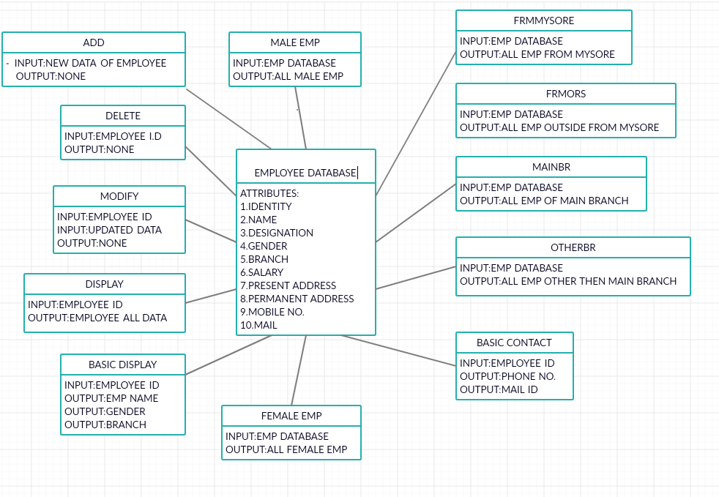

**TEST PLAN:**

**HIGH LEVEL TEST PLAN (INTEGRATION)**

|  |  |  |  |  |  |
| --- | --- | --- | --- | --- | --- |
| **ID** | **DESCRIPTION** | **PRE-CONDITION** | **EXPECTED I/P** | **EXPECTED O/P** | **ACTUAL O/P** |
| It_01 | Name mismatch | Correct database is present | Wrong input | Error will arise |  |
| It_02 | No two employees should have same id | Unique id must be provided | Entering the same employee id | Error should arise |  |
| It_03 | Invalid id | Thumb impression should be available in attendance machine | Outsider puts his thumb on attendance machine | Sorry, not matched |  |
| It_04 | Similar name | Unique id is present | Name mapped and employee id | Correct person is matched |  |

**LOW LEVEL TEST PLAN (UNIT)**

|  |  |  |  |  |  |
| --- | --- | --- | --- | --- | --- |
| **ID** | **DESCRIPTION** | **PRE-COND** | **EXPECTED I/P** | **EXPECTED O/P** | **ACTUAL O/P** |
| UT_01 | Employees salary should be only numeric | Employee salary | In the form of digits | Should be in the form of digits |  |
| UT_2 | Employee name should contain only alphabet | Employee name | Should contain only alphabet | In the form of alphabet |  |
| UT_3 | Employee id should contain only numeric | Employee id | Employee id number | Should be in the form of digits |  |
| UT_4 | Employee age should be in the form of numeric | Employee age | In the form of digits | Age should be in the form of digits |  |

GIT REPOSITORY:

1. <https://github.com/99002588/SDLC-Genisis>

**MAKEFILE**

|  |
| --- |
| SRC = main.c\ |
|  | src/e1.c\ |
|  |  |
|  | INC = -Iinc |
|  |  |
|  | PROJECT_NAME = been.out |
|  | BUILD = build |
|  |  |
|  | $(PROJECT_NAME): $(SRC) |
|  | gcc $(SRC) $(INC) -o $(PROJECT_NAME) |
|  |  |
|  | run:$(PROJECT_NAME) |
|  | ./${PROJECT_NAME} |
|  |  |
|  |  |
|  | clean: |
|  | rm -rf $(PROJECT_NAME) documentation/html |
|  | $(BUILD): |
|  | mkdir build  **BUILD** |

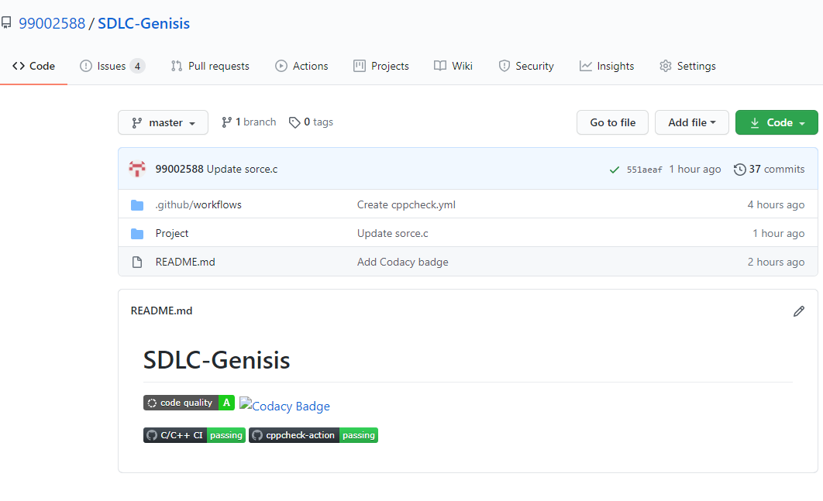

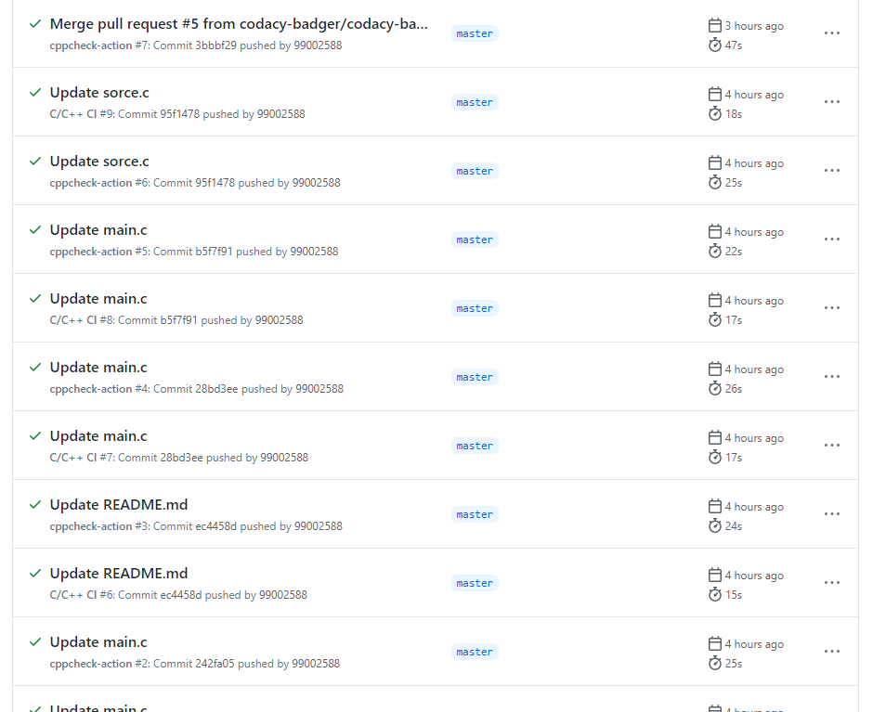

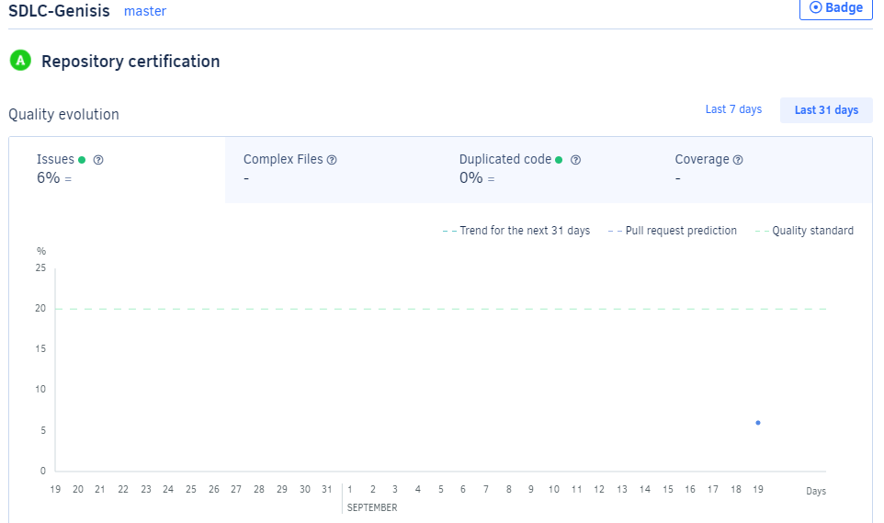

**REFERNCES:**

1. <https://github.com/99002588/SDLC-Genisis>
2. <https://app.creately.com/diagram/pYpHDpd2Psk/edit>
3. <https://app.codacy.com/manual/99002588/SDLC-Genisis/dashboard>
4. <https://www.includehelp.com/c-programs/c-structure-and-union-program-to-read-and-print-an-employee-details-using-structure.aspx>